EXPT NO:4 | TRANSFORM DATA TO SUIT BI REPORTING REQUIREMENTS AND  DESIGN A DASHBOARD WITH KEY PERFORMANCE INDICATORS (KPIs ) USING TABLEAU AND POWERBI
DATE: 24.07.2026

PRE-LAB QUESTIONS (PROVIDE BRIEF ANSWERS TO THE FOLLOWING QUESTIONS)
1. What is the role of data transformation in BI reporting?
Data transformation converts raw data into a clean and structured format suitable for analysis. It includes correcting data types, handling missing values, and creating calculated fields. This process improves data quality and ensures accurate reporting and visualization in BI tools.

2. What are the common data cleaning techniques in Tableau and Power BI?
Common data cleaning techniques include handling missing values, removing duplicates, correcting data types, and standardizing text values. Tableau uses calculated fields and Data Interpreter, while Power BI uses Power Query for cleaning and transforming data. These techniques improve data accuracy and consistency.

3. How do Tableau and Power BI handle data aggregation?
Tableau and Power BI automatically aggregate numerical data using functions like SUM, AVG, COUNT, MIN, and MAX. Users can also change the aggregation method based on analysis requirements. This helps summarize large datasets and generate meaningful insights through visualizations.

4. What are KPIs, and why are they important in a dashboard?
Key Performance Indicators (KPIs) are measurable values that show how effectively a business is achieving its objectives. They provide a quick overview of important metrics such as sales, profit, or revenue. KPIs help decision-makers monitor performance and make informed business decisions.

5. What are the different types of charts available in Tableau and Power BI for visualization?
Tableau and Power BI offer various visualization types, including bar charts, line charts, pie charts, scatter plots, maps, tree maps, heat maps, histograms, and KPI cards. These charts help users analyze trends, compare categories, identify patterns, and present data effectively through interactive dashboards.

IN-LAB EXERCISE:
OBJECTIVE:
To transform COVID-19 data into a structured format suitable for Business Intelligence (BI) reporting and design interactive dashboards with Key Performance Indicators (KPIs) using Tableau and Power BI.

PROCEDURE:
- Data Collection:
  - Import the COVID-19 dataset from inbuilt sources like Our World in Data or CSV files containing country-level COVID statistics (e.g., new cases, deaths, vaccinations).
  - Datasets may include fields such as date, location, new_cases, total_cases, new_deaths, total_deaths, people_vaccinated, etc.
- Data Cleaning and Transformation:
  - Convert columns like date to proper date formats.
  - Handle missing or null values in new_cases, total_cases, etc.
  - Create calculated fields (e.g., daily case growth rate, case fatality rate, vaccination percentage).
- Data Aggregation:
  - Aggregate data by continent, country, or month.
  - Use measures like SUM(new_cases), AVG(positivity_rate), MAX(total_deaths).
- Designing KPIs:
  - Identify KPIs such as:
    - Total Confirmed Cases
    - Total Deaths
    - Case Fatality Rate
    - Vaccination Coverage (%)
    - Daily Case Growth Rate
  - Use DAX (Power BI) or Calculated Fields (Tableau) to compute and visualize these KPIs.
- Dashboard Development:
  - Build visualizations such as:
    - Line charts for daily new cases and deaths
    - Bar charts for country-wise vaccination progress

    - Maps to show regional case distribution
    - KPI cards for high-level insights
  - Use filters (e.g., by continent, country) and slicers (e.g., by date range) for interactivity.
- Publishing and Sharing:
  - Publish the dashboard using Tableau Public/Server or Power BI Service.
  - Share the dashboards with stakeholders through public or organizational portals.
Experiment Dataset:
COVID-19 Global Dataset Fields Used:
  - Date – Date of the report
  - Location – Country or region
  - New Cases – Daily reported cases
  - New Deaths – Daily reported deaths
  - People Vaccinated – Cumulative vaccinated count
  - Total Cases – Cumulative confirmed cases
  - Total Deaths – Cumulative deaths
  - Population – Total population of the country

TABLEAU:

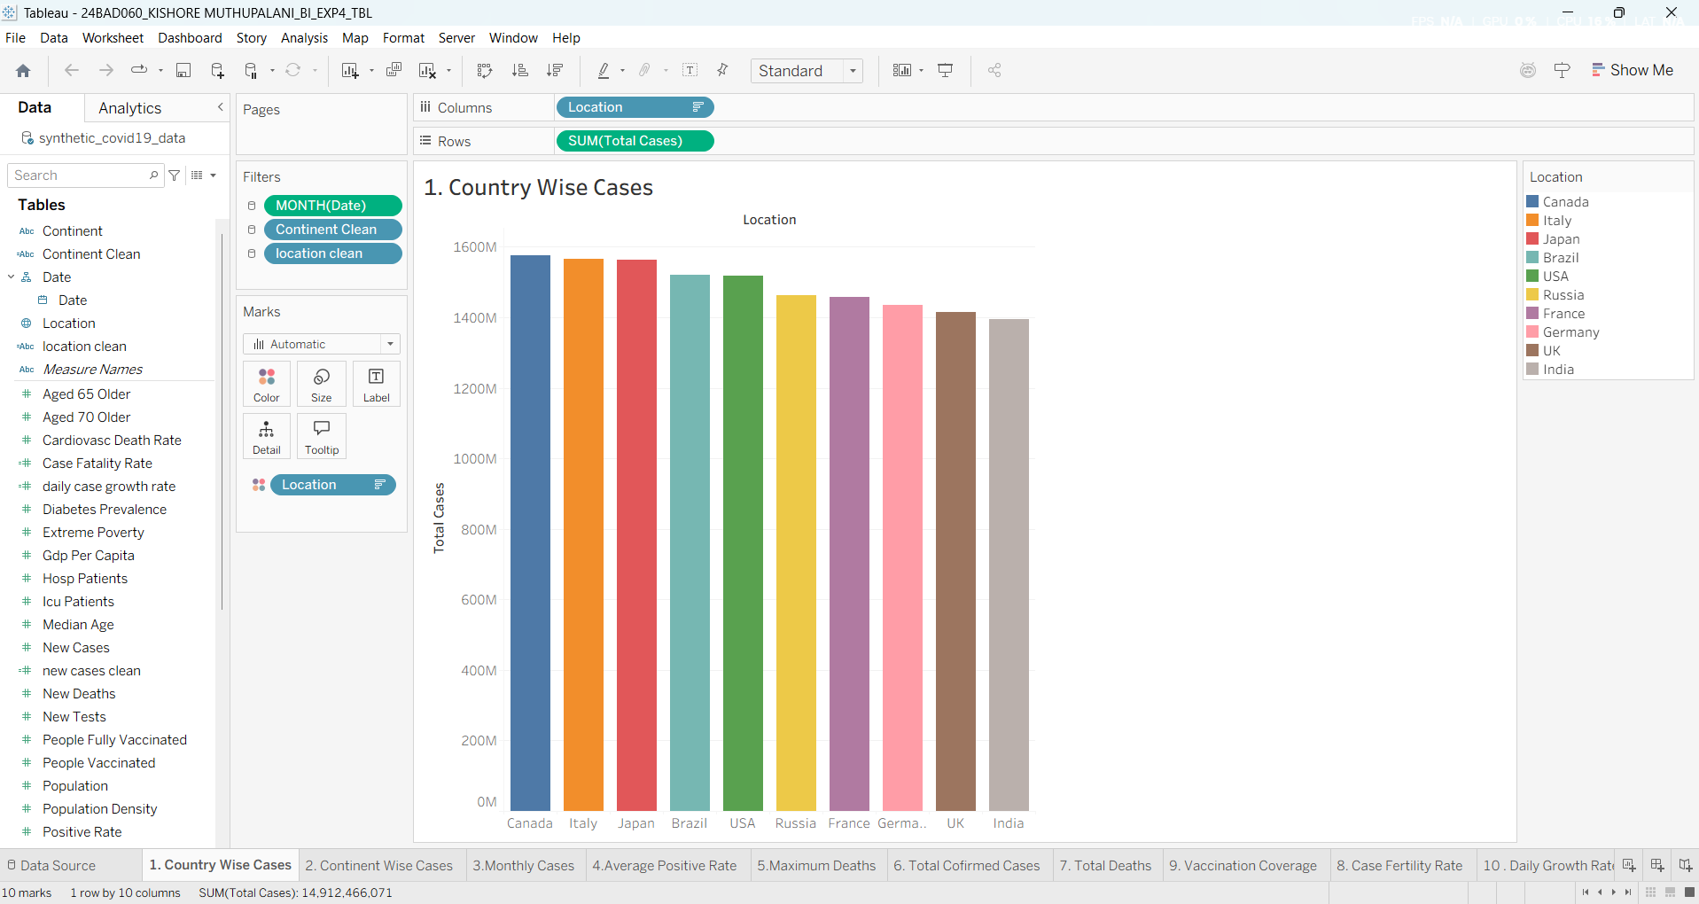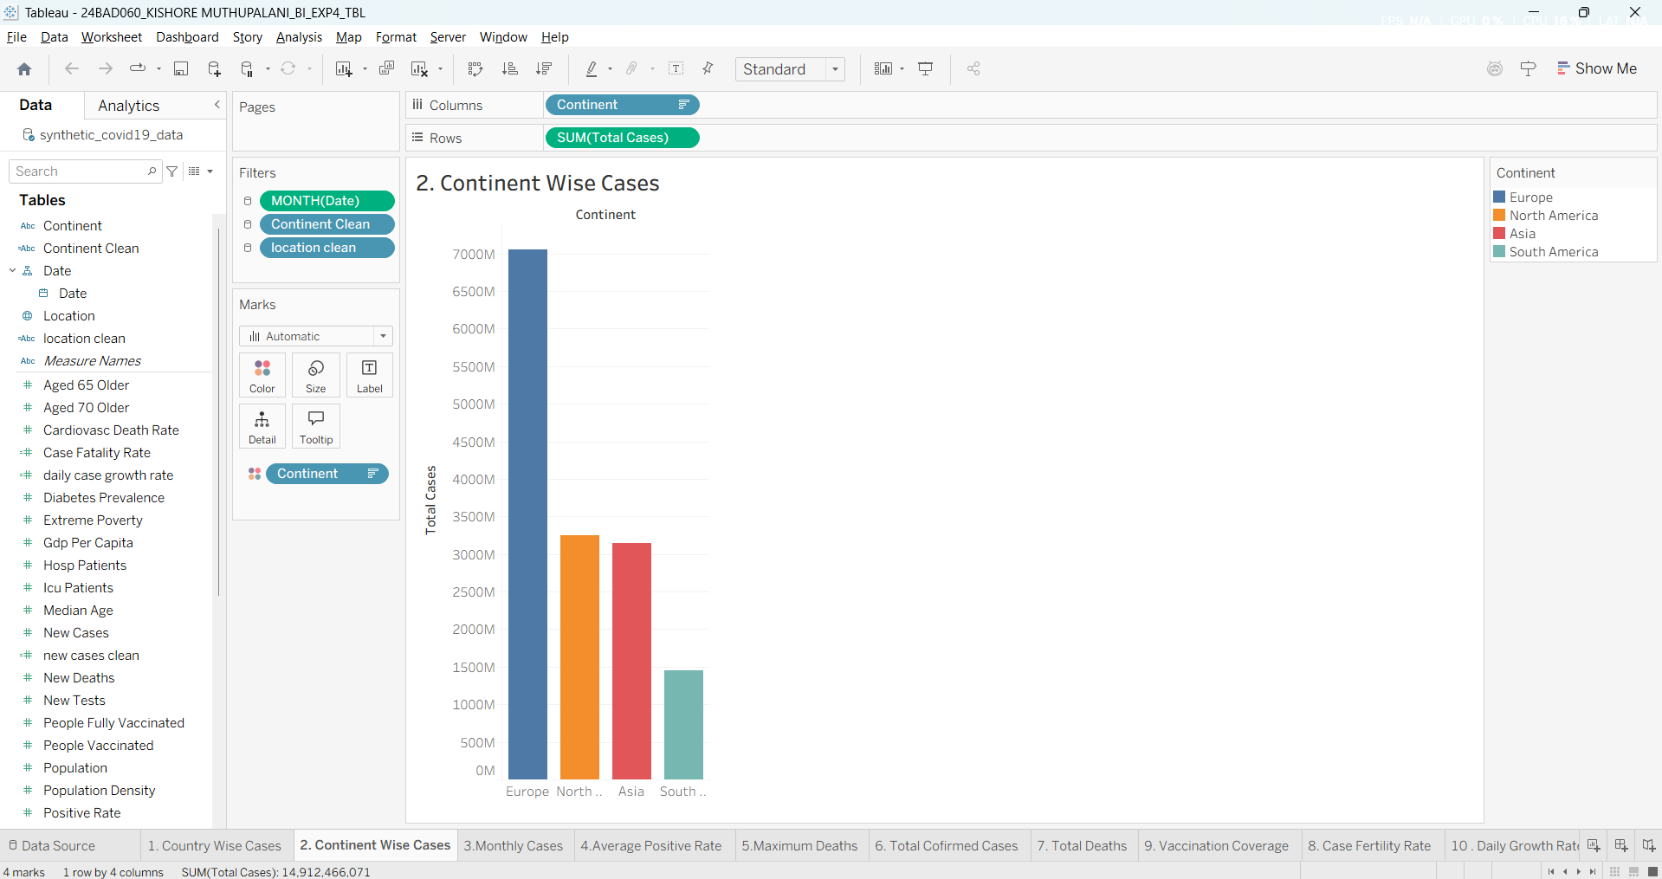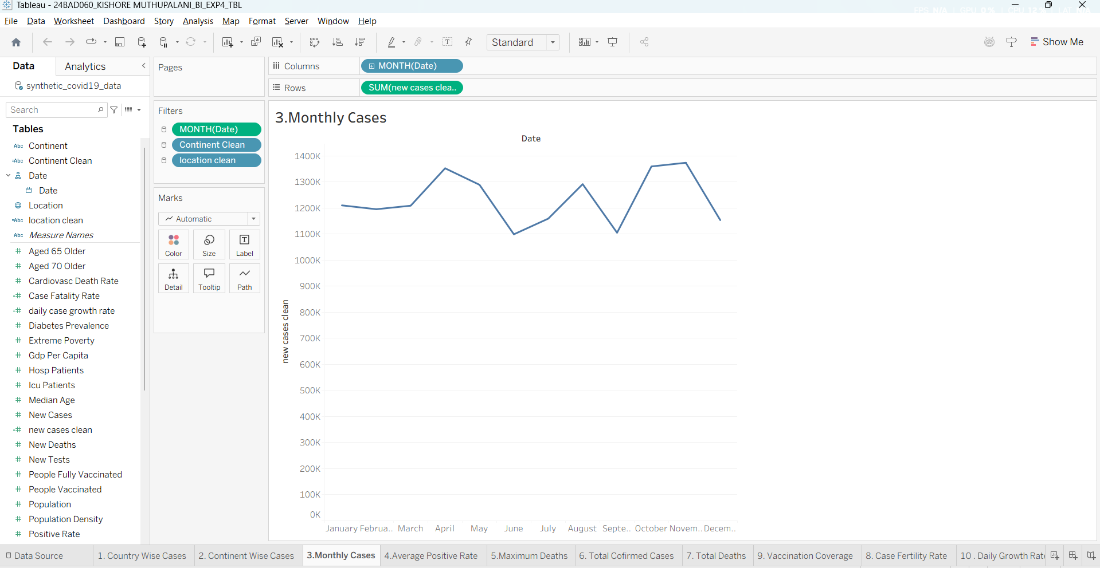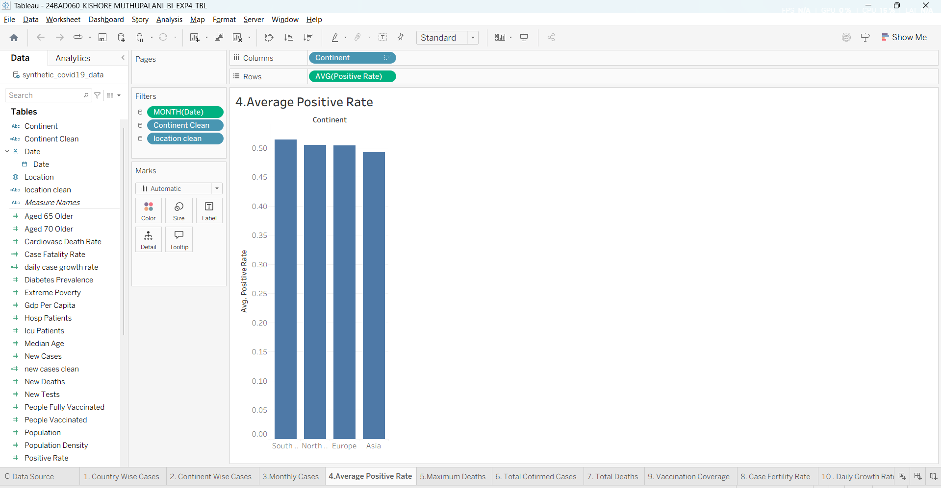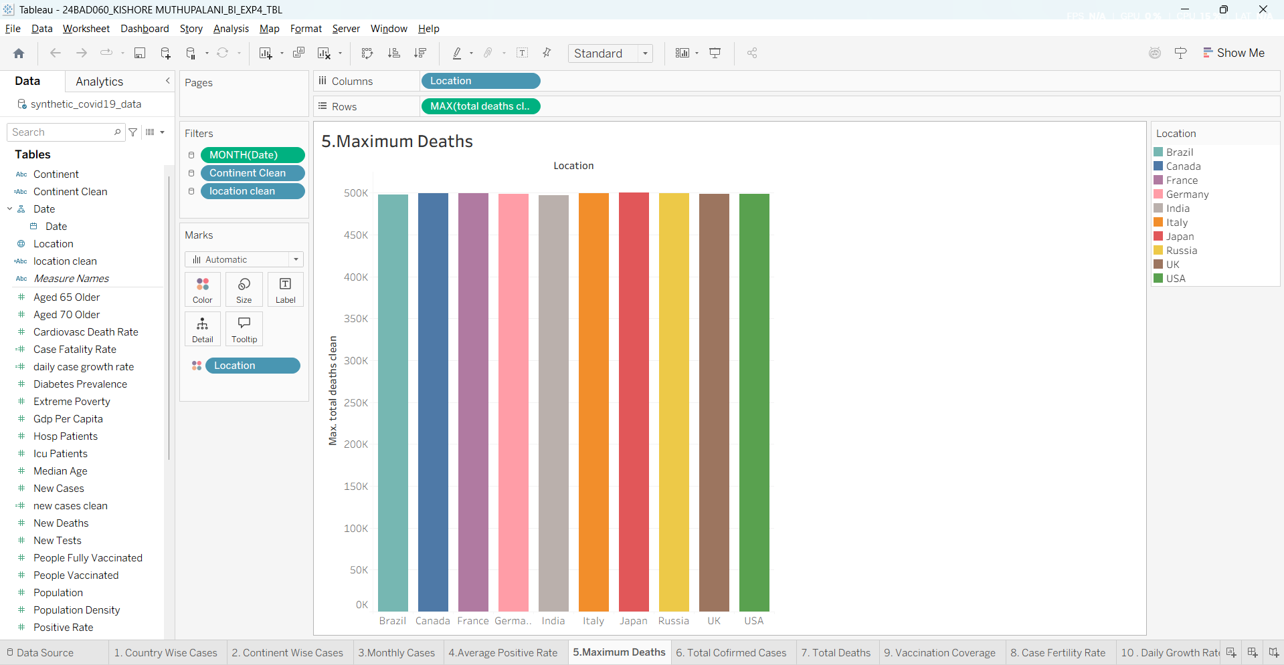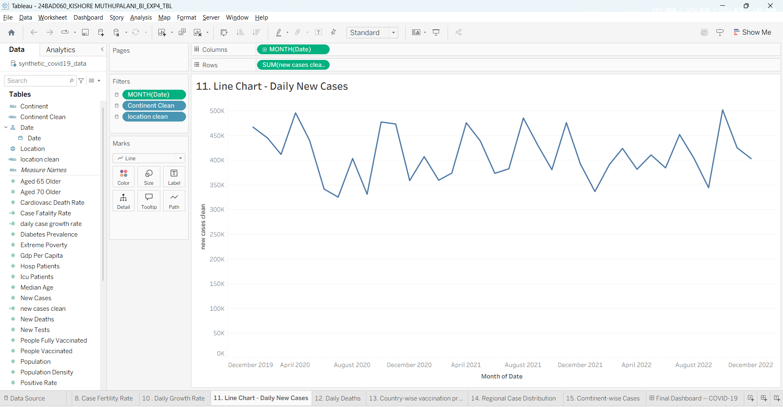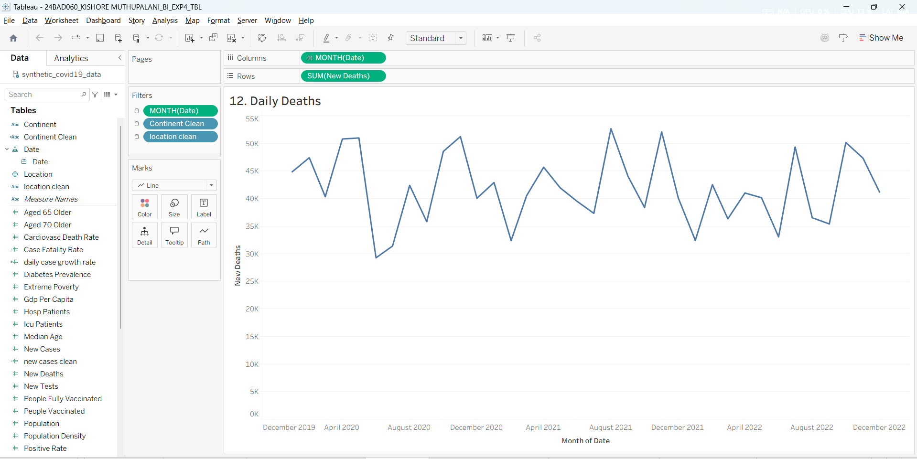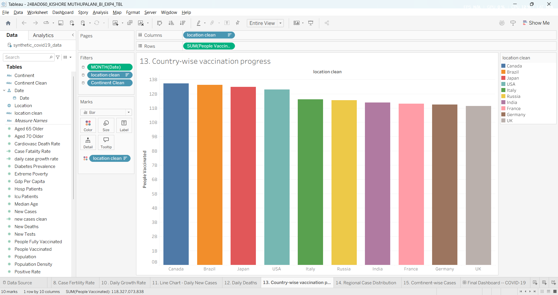
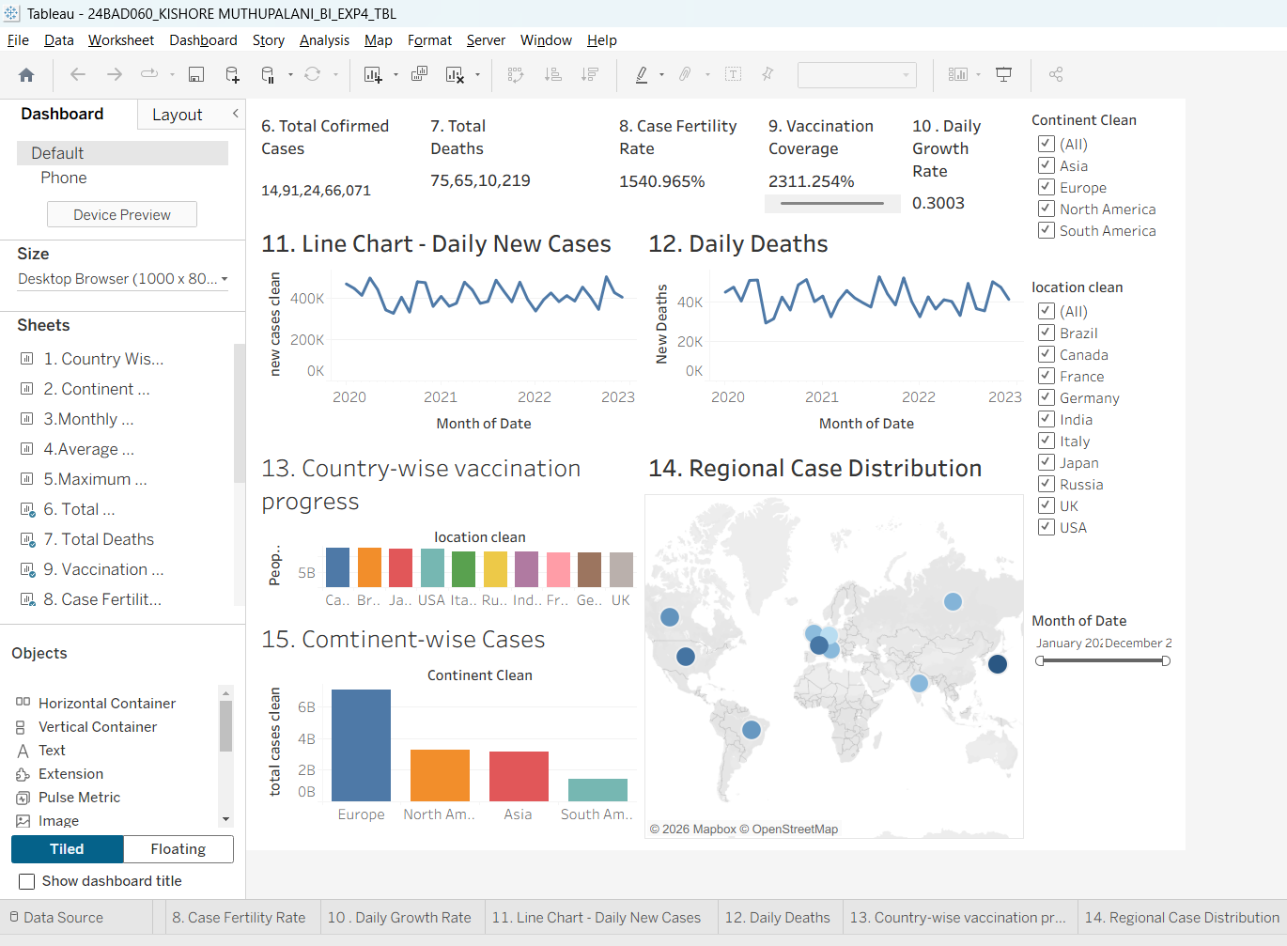

POWERBI:
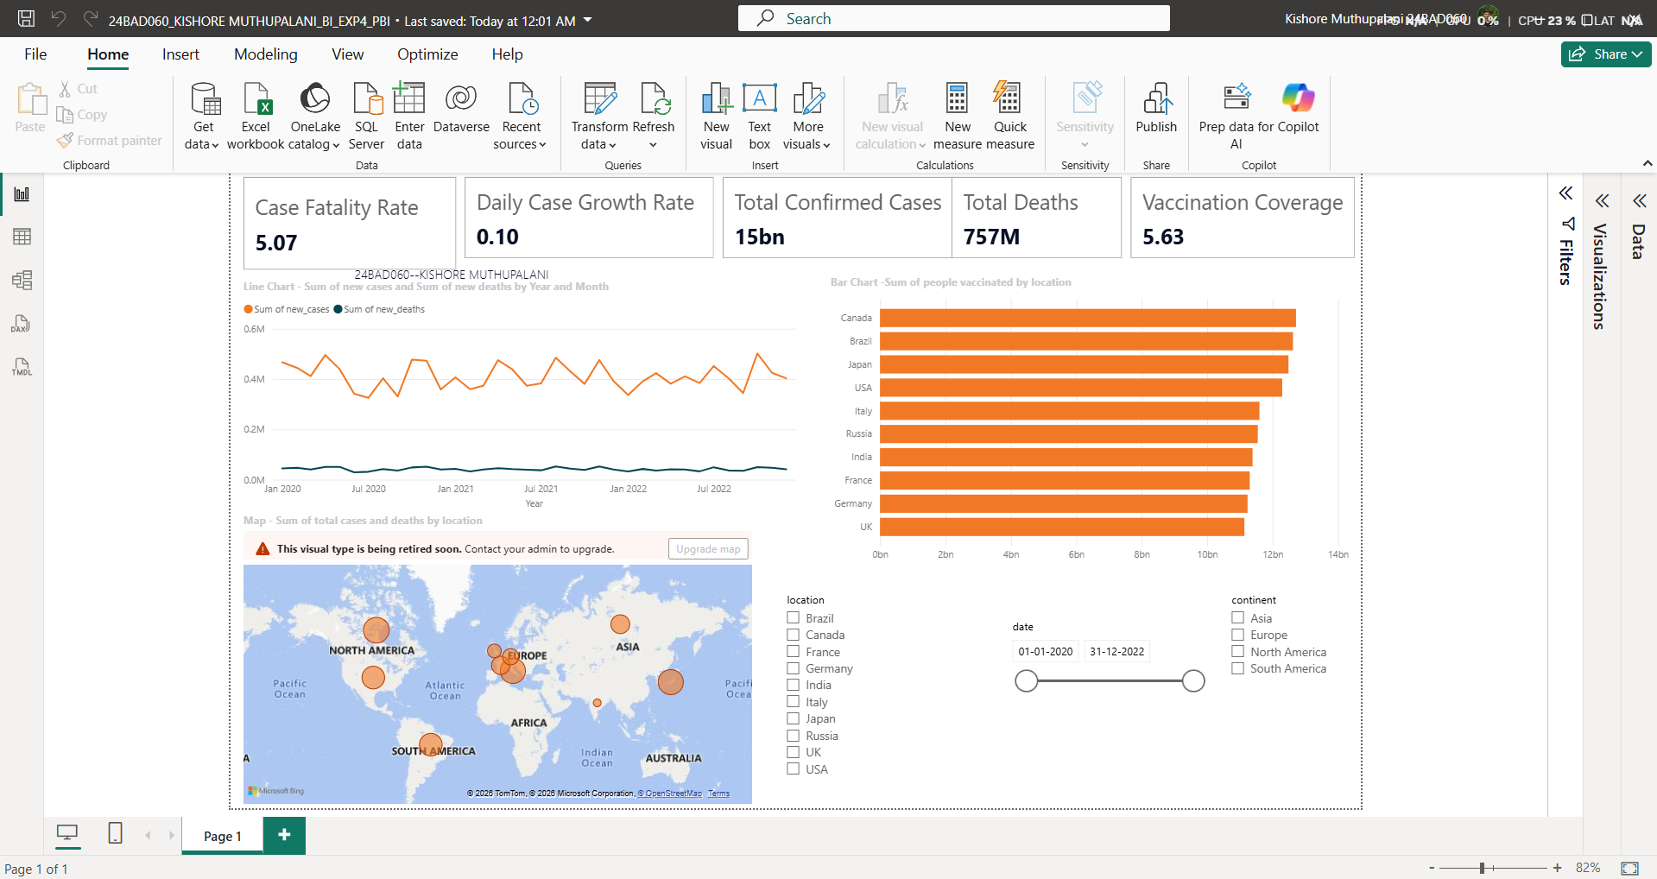

POST-LAB QUESTIONS (PROVIDE BRIEF ANSWERS TO THE FOLLOWING QUESTIONS)

1. How did data transformation improve the quality of insights in your COVID-19 dashboard?
Data transformation improved the dashboard by converting the Date field into a proper date format, replacing null values in fields such as New Cases, Total Cases, and Total Deaths, and creating calculated fields like Case Fatality Rate, Vaccination Coverage, and Daily Case Growth Rate. This enabled accurate KPI calculations, such as 1,491,246,607 total confirmed cases and 756,510,219 total deaths, while supporting reliable monthly trend analysis and country-wise comparisons.

2. What challenges did you encounter during the data cleaning process, and how did you resolve them?
The main challenges were handling missing values in COVID-19 metrics and ensuring the Date column was correctly recognized for time-based analysis. I resolved these issues using IFNULL() calculated fields to replace null values with appropriate defaults and standardized text fields such as Continent and Location. This ensured that all charts, KPIs, and filters worked correctly without missing or inconsistent records.

3. Which KPI provided the most valuable insight, and why?
The Vaccination Coverage KPI provided the most valuable insight because it reflected the overall vaccination progress across countries. The dashboard showed Canada with the highest vaccinated population (approximately 12.7 billion cumulative vaccinations) among the selected countries, while the overall vaccination coverage metric highlighted large differences between regions. Combined with total confirmed cases and deaths, this KPI helped assess the effectiveness of vaccination efforts.

4. How does interactivity in dashboards improve user experience?
Interactive filters and slicers significantly improved the dashboard's usability by allowing users to filter data by Continent, Country, and Date Range. Selecting a specific country instantly updated the KPI cards, line charts, vaccination chart, and regional map. This enabled users to compare trends, analyze monthly case variations, and focus on individual regions without creating separate reports.

5. What steps would you take to further enhance the dashboard’s effectiveness?
To improve the dashboard further, I would add forecasting for future COVID-19 cases, include hospitalization and ICU occupancy trends, and introduce drill-down functionality from continent to country level. I would also improve KPI formatting by displaying percentages correctly (e.g., Case Fatality Rate and Vaccination Coverage), add conditional color indicators for high-risk regions, and include dynamic tooltips with additional statistics to make the dashboard more informative and user-friendly.

RESULT:

The COVID-19 dataset was successfully cleaned, aggregated, and transformed for visual analysis using Tableau and Power BI. Missing values, data type mismatches, and inconsistencies were addressed. KPIs such as vaccination rate and daily case growth offered valuable insights into the pandemic trends across countries and timeframes. The resulting interactive dashboards allowed for effective public health monitoring and communication.

ASSESSMENT

Description | Max Marks | Marks Awarded
Pre Lab Exercise | 5
In Lab Exercise | 10
Post Lab Exercise | 5
Viva | 10
Total | 30
Faculty Signature

